INFORMATION SHEET AGES 6-10

UK Histiocytosis Registry

What is research? Why is this project being done?
Research is a way we try to find out answers to questions. We want to see why some of the cells in your body aren’t working properly. We need to know more about these cells to find out what makes you poorly and to make medicines work better.

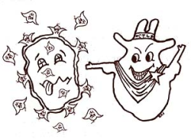
Why are you asking me?
We are asking you to take part because you have had tests done in hospital to find out why you are poorly and how to make you better

Do I have to say yes?
Not if you don’t want to. It is up to you and your mum and dad or guardian. Nobody will mind if you don’t want to take part. You can change your mind any time.

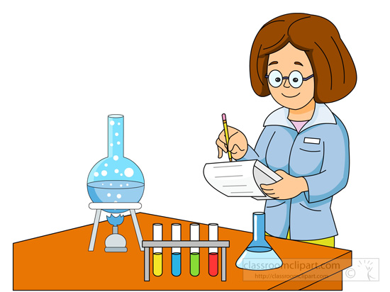
What will happen to me?
If you decide to take part, we will keep some of the blood and operation samples that were taken from you. The samples will then be given to a scientist to do the research. We will also ask your doctor to tell us about you.

Will it hurt or upset me?
We don’t think so. We just need to ask your doctor some questions. We might ask you some questions too.

Will joining in help me?
We don’t think that it will help you but it might help other children like you in the future. If there is anything that will help your doctors to look after you then we will tell them.

What if I don’t want to do the research anymore?
You can stop at any time. If you don’t want to do the research anymore, just tell your parents, doctor or nurse. They will not be cross with you.

What if I think there is a problem?
If there is any problem during the study, just tell your parents, doctor or nurse and it will be sorted out as soon as possible.

Will anyone else know I’m doing this?
Only your family and your doctors and nurses will know that you are doing this. No-one else will be able to see your name or know that you are taking part.

Did anyone else check that the study is OK to do?
Before any research is allowed to happen, it has to be checked by a group of people called a Research Ethics Committee. They make sure that the research is fair. Your project has been checked by the Newcastle & North Tyneside 2 Research Ethics Committee.

Thank you for reading this.

